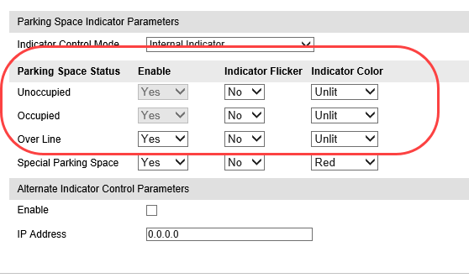

PUT API

<?xml version="1.0" encoding="UTF-8"?>

<LampCtrlDescription>

    <LampCtrlMode>1</LampCtrlMode>

    <ParkingTotalNum>3</ParkingTotalNum>

    <nocarLampStats>32768</nocarLampStats>

    <haveCarLampStats>32768</haveCarLampStats>

    <pressLineLampStatus>32768</pressLineLampStatus>

    <specialParkingLampStatus>32771</specialParkingLampStatus>

</LampCtrlDescription>

Authen : Diggest Auth

Decimal 32768 corresponds to hexadecimal 8000, the first 8 means enable, usually 8;The first 0 indicates whether or not it blinks (0/1);The last two 00's represent the color of the headlights. For example, red is 01.Therefore, 32769(hexadecimal 8001) indicates the indicator light is on, which is red;32771(hexadecimal) means the indicator light is on, which is yellow;